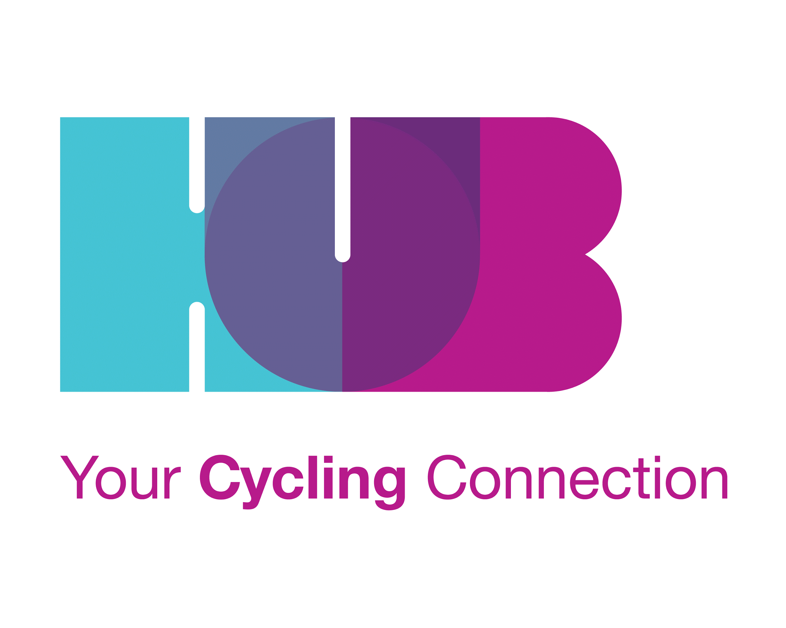
HUB Cycling Board Director Application and Information Form 2017

Please submit the completed application to elections@bikehub.ca by Friday, June 30th, 2017.

Please note: HUB’s Board Development Committee will prepare a summary of each candidate to distribute and post on our website prior to the AGM, based on information provided in this application. The Committee may also identify recommended candidates based on the skills sought.

About HUB: HUB Cycling is a charitable, non-profit society that works to make cycling better through education, action, and events. We believe more people cycling creates healthier, happier, more connected communities. We’re leading the way in making cycling an attractive choice for everyone in Metro Vancouver.

HUB believes that increased bicycle use reduces traffic congestion, improves health conditions, and enhances our urban environment. HUB works to encourage bicycle use: to provide and improve cycling facilities, to educate cyclists in commuter cycling skills, and to encourage cycling as an embraced mode of transportation. HUB took an active role in allowing bicycles on the SkyTrain, in supporting the separated bike lanes in downtown Vancouver, and many improved cycling routes and facilities in other municipalities. HUB gained charitable status in 2012 for our educational activities promoting environmental, health, and society benefits through cycling.

HUB runs Bike to Work Week in May and November, teaches safe cycling skills at community centres, workplaces, and schools (Streetwise Cycling and Bike to School), engages the business community with its Bike Friendly Business program, and holds cycling-related events throughout Metro Vancouver. Please visit www.bikehub.ca for more information.

BOARD CANDIDATE
NAME:
ADDRESS:
CITY: POSTAL CODE:
TELEPHONE: EMAIL:
OCCUPATION: HUB MEMBER (Yes/No)
PREVIOUS VOLUNTEER BOARD EXPERIENCE (Yes/No):
OTHER BOARD EXPERIENCE? (CORPORATE, ETC) (Yes/No):

1. History of Board experience and other volunteer work: (Please briefly list dates and responsibilities.)

2. Please list 2 examples of specific contributions you’ve made while serving on a previous Board / Committee / Team in a volunteer setting. Contributions from a professional setting could also be included, though volunteer examples may be more relevant.
1.
2.

3. History of employment or other interests (please briefly list dates and responsibilities):

HUB STRATEGIC OVERVIEW

Our Mission: To get more people cycling, more often.

Our Vision (updated 2015): In Metro Vancouver in 2030, cycling is an attractive transportation option because it is fun, safe, convenient and comfortable for people of all ages and cycling abilities.
Investment in cycling is aligned with ambitious government mode share goals, cycling education is universally accessible and cycling facilities are connected throughout the region.

Our Core Values (updated 2015):
As Metro Vancouver's most recognized and respected cycling transportation organization we:
- Respect all forms of transportation
- Value cycling as a community building tool & as a healthy practice for individuals & our environment
- Provide inclusive, forward-thinking programs and services, known for engagement and empowerment of the community and their transportation choices
- Avoid funding or support that could compromise the integrity of our mission, purpose or values

Strategic Priorities 2015-2020:

1. Better engage all cycling stakeholders & create positive change
2. Improve financial strength
3. Increase public engagement

4. In 50 words or less, what is your vision for cycling in Metro Vancouver, or how do you feel about cycling for transportation? HUB may include this on our website and hand out to members at the AGM prior to the election.

BOARD OVERVIEW
Term: 2 years, roughly Sept - Sept. A portion of the Directors is elected each alternating year.
Composition: 11 Directors, elected by members at AGM
Executive Officers: President, Vice-President, Secretary, Treasurer
Members at Large: Oversee specific areas of the organization via work on Board Committees (Regional Advisory; Operations; Board Development; Fund Development), and support local committees that deal with issues specific to each Metro Vancouver municipality by attending different local committee meetings from time to time. All Directors are actively involved in at least one Board Committee; attendance at two is encouraged to cover Board duties. Board Meetings are chaired by the President, or VP in case of President’s absence.
Vacancies for 2017 Board: 4 Director positions will be open to election. Of these positions, please note that up to 3 current Directors will stand for re-election.
Collective Board Skills Required: Finance, fundraising, operations management, business skills, non-profit/charity governance, organizational development, legal, knowledge of the cycling community, cycling advocacy, marketing, communications, member/stakeholder engagement, human resource management.
Skills & Experience Sought for 2017 Board:
- Great fundraising connections and an interest in fundraising
- A passion for and knowledge about cycling infrastructure, planning and engineering
- Strategic thinking and change management skills
- Sufficient time available to be an excellent ambassador for HUB Cycling (at least 10-12 hours per month)

Demographics:
- We particularly encourage candidates from Metro Vancouver municipalities outside Vancouver itself - although Vancouver candidates are also welcome.
- We strive to further diversify the Board through a wide range of ethnicities, ages, genders, and backgrounds.

5. From the list of 2017 Board needs, what skills and/or experience would you bring to the Board? Feel free to describe other relevant skills that would be of assistance to the position. (Between 40-150 words.)

Regular Board Meetings: 2nd Wednesday of each month. 6:30-9:00 pm. Please ensure you are generally available to meet at this time. Location: HUB Cycling Office, 1—828 West 8th Avenue, Vancouver (relocating in the fall to 312 Main Street, Vancouver)
Time Commitment: Board Directors spend a minimum of 10 hours per month on HUB Cycling work, including preparation for and attending Board meetings, corresponding by email and voting in electronic motions, fulfilling Action Items from Board meetings, and taking an active role in at least one Board Committee. Committees generally meet on a monthly basis. During Bike to Work Week and other events, Board members may participate in additional events. Depending on individual level of involvement and commitment, this time may increase. It is also recommended that Board Directors visit (or regularly attend) a Local Advocacy Committee meeting in their municipality and/or adjoining municipalities.
6. How do you feel about committing this time to a Board Director position?

7. How many hours per month can you commit in a Board Director role?

8. Do you anticipate any problem with committing to the full 2-year term?

Roles and Responsibilities of the Board: The HUB Board of Directors is a Working Board and a Governance/ Policy Board. In addition to setting policies and approving the annual budget, the Board sets short- and long-term goals for the Society, guides the Society’s programs and services, ensures funding is secured, oversees the Society’s human resources through the placement and overview of the Executive Director, and directs communications with external stakeholders.
Responsibilities of the Board Jointly:
· represents, and is responsible to, the community
· provides leadership by setting goals, objectives, and priorities for the Society
· establishes and oversees the policies of the Society
· follows the Constitution and By-laws which govern the Society’s organization and activities
· ensures the Society has the funds and facilities to operate
· ensures the Society is operating according to the Society Act
· informs the community about the Society and our work
· advocates for the needs of our constituents
· works with other societies, agencies, and services

Responsibilities of Individual Board Members:
· attend all Board meetings
· phone or e-mail if you must be late or absent
· take an active part in Board and Society activities
· participate in Committee work
· respect the confidentiality of sensitive information
· review reports and minutes and be prepared to discuss them
· share responsibility for all projects undertaken by the Board on behalf of the Society (fundraising, special events, etc.)
· recruit Board and Committee members
· actively represent HUB in the community as ambassadors
· make a charitable donation to HUB (according to own ability)
· commit and be accountable to playing a role in new fundraising activities (e.g. make introductions, open doors, enlist new donors, etc)
· learn as much as possible about:
a. HUB
b. cycling issues in Metro Vancouver
c. other related agencies and organizations in the community

Board of Directors’ Liability: A Board of Directors is the legal entity for a non-profit organization. Board members are legally responsible for the activities of the Board. HUB maintains a comprehensive insurance policy with a $5 million limit for commercial general liability (including directors) and a $2 million limit for other director liability. For more general information, one resource is the Volunteer Canada paper entitled: Directors’ Liability: A Discussion Paper on Legal Liability, Risk Management and the Role Of Directors in Non-Profit Organizations: www.volunteer.ca/volunteer/pdf/LiabilityEng.pdf.

9. Please include a short bio (75-100 words) that HUB may include on our website and hand out to members at the AGM prior to the election.

Pre-Election Candidate Orientation: An in-person meeting with candidates, or a group orientation session, may be held to further describe the position, answer questions, and assist the Board and the candidate with assessment of fit between the candidate and a HUB Director role. The Board Development Committee will set this up after applications have been received. Orientation Resources: Board Reference Manual, website www.bikehub.ca, and current Board Directors.

CANDIDATE INTENTION
If selected, please allow my name to stand for nomination to the HUB Board of Directors. I have read the above information and am willing to commit my time to HUB.

___________ ________ ___________________________
Type Name as Signature Date

* Only HUB Members are eligible for Board positions. If a candidate is not yet a HUB member, online Membership payment is available at https://bikehub.ca/join or the Membership Form may be downloaded and submitted with payment anytime before taking office, including in person at the Annual General Meeting.
Thank-you for your interest in applying for the HUB Board of Directors.
We appreciate your engagement! We would like to welcome you, and encourage you to take an active role in the organization, whether as a Director, volunteer or supporter. Your participation is highly appreciated! There are many effective ways to become involved with your time as a member or volunteer. If you have some of these skills but are not able to commit to the position of Board director, we would love to chat with you about joining a topic-specific committee (such as fundraising, membership, advocacy, etc.) Email volunteer@bikehub.ca
Donations and financial support is always welcome and put to effective use. Donations are eligible for charitable tax credits: bikehub.ca/donate
The Board Director Election will be held at the Annual General Meeting on September 23 2017. More information about the election will be provided via email and at the Pre-Election Orientation meetings. See www.bikehub.ca for AGM details.
Warm regards, and keep your spokes spinning…

Please contact elections@bikehub.ca with any questions. Return completed applications by Friday, June 30, 2017.

